**P3**

**Introduction**

In this assignment, I will be explaining the software utilities e.g. security – virus protection, clean up tools-, drive formatting, back-up utility, internet history, defragmentation, firewall and diagnostic utility.

Software utilities are types of programmes that helps to improve the system. It can secure, maintain, manage, back-up, and delete any files that are on the system. To view the software utilities, you have to follow the steps that Figure 1.1 demonstrates. Firstly, click on the start button. Browse accessories and system tools shows all the software utilities.



Figure 1.1

**Virus protection**

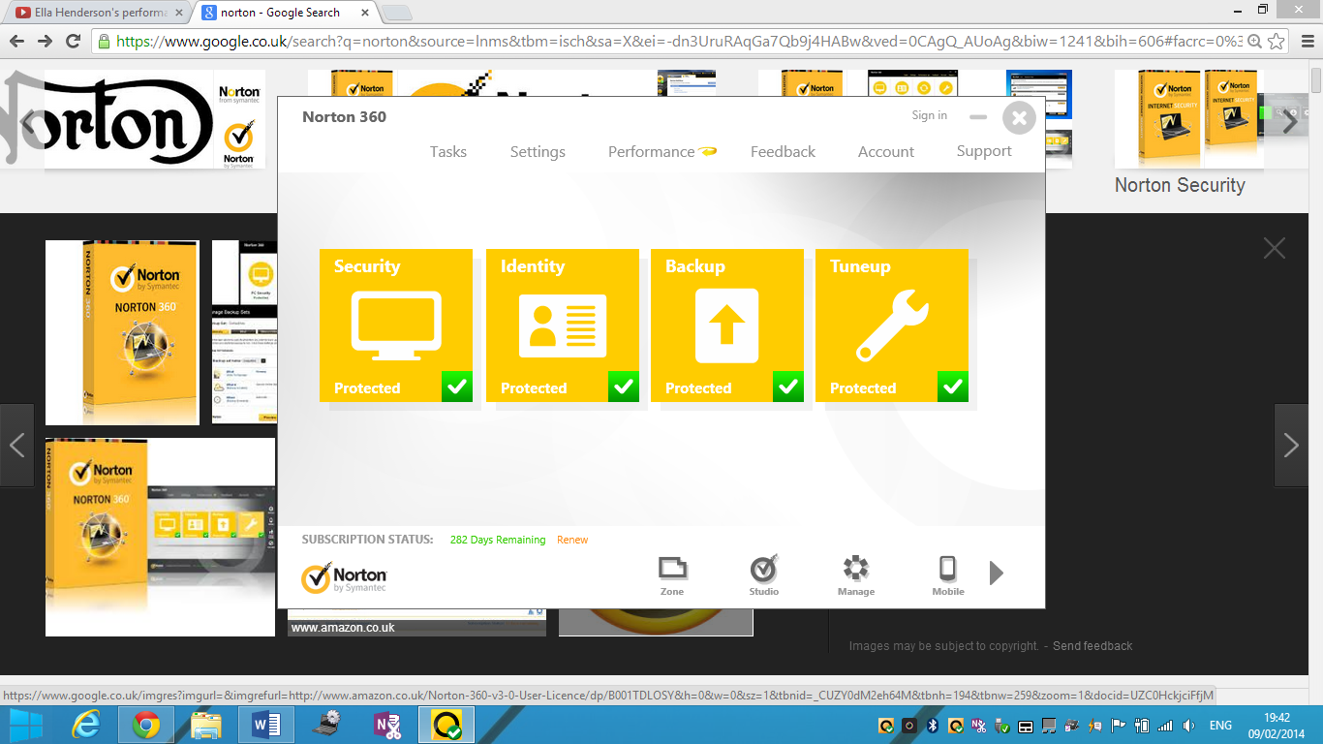A virus protection is a software, which can be found on any personal computer that is used to prevent, detect and remove malware. The main types of software protections are:

* Norton
* McAfee
* Kaspersky

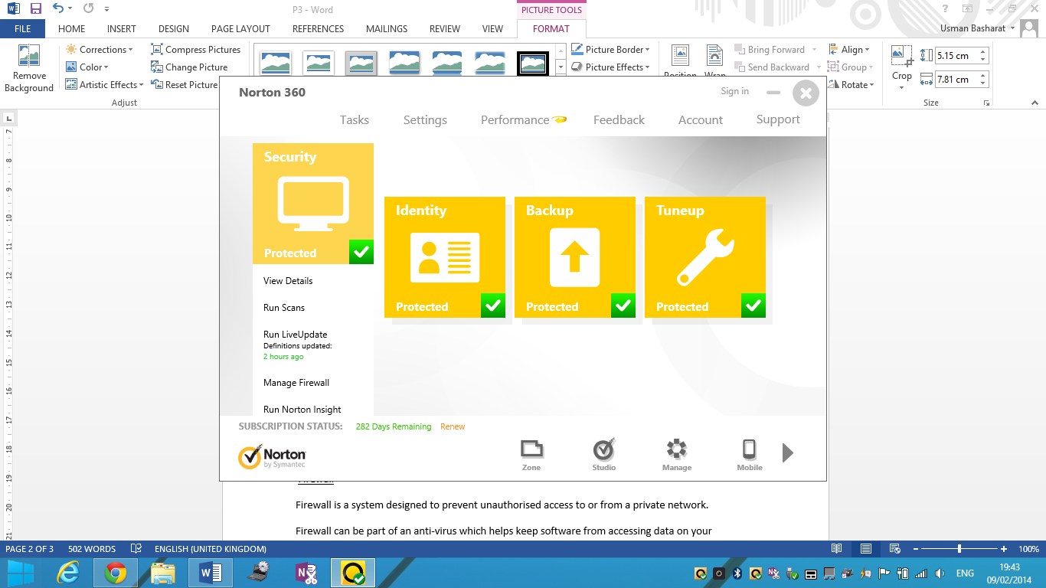These can be used to scan the computer for any viruses. Once scanned, it should show how many viruses they are on the computer. Every computer/laptop device should have a virus protection to prevent any viruses attacking the computer. As you can see below, it shows details of the how clear the virus protection presents itself. It is very easy to use.

**Customer Review**

“**Wonderful Value,** the software arrived on time and worked perfectly!”

<http://www.amazon.com/Norton-360-2013-Version-Download/product-reviews/B008SCNLEY>

**Firewall**

[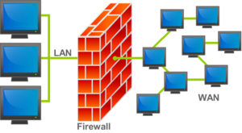](http://en.wikipedia.org/wiki/File:Firewall.png)Firewall is a system designed to prevent unauthorised access to or from a private network. Firewall can be controlled by a virus protection e.g. Norton. It controls any incoming and outgoing network traffic. Referring to Figure 1.1, it shows how the firewall works. It is a ‘wall’ that separates the LAN and WAN. The user has to turn on the Firewall in order to protect the computer. The Firewall can be either controlled by your anti-virus or it can be turned on by your computer. If Google Chrome tries to access your personal files, Firewall will prevent Google Chrome from accessing the computer.

**Clean-up tools**

Clean-up tools is computer maintenance utility, included Microsoft Windows, which frees up space. It deletes any unnecessary files that is not needed. It could delete the following files:

* [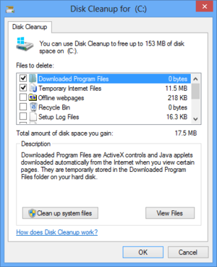](http://en.wikipedia.org/wiki/File:Windows_Vista_Disk_Cleanup.png)Downloaded program file
* Temporary internet files
* Offline Web Pages
* Recycle bin
* Temporary files
* Removal of unused applications or optional Windows components
* Setup log files
* Offline files

Clean up tools are like defragmentation or an anti-virus, which scan your computer or search your computer to find software of files that are never used. It just a waste of space and delete them because they do not need the files or software to run the system. It’s just a waste of space. You have to select the files you want to permanently delete. Beside it shows how many files are in the selected one.

[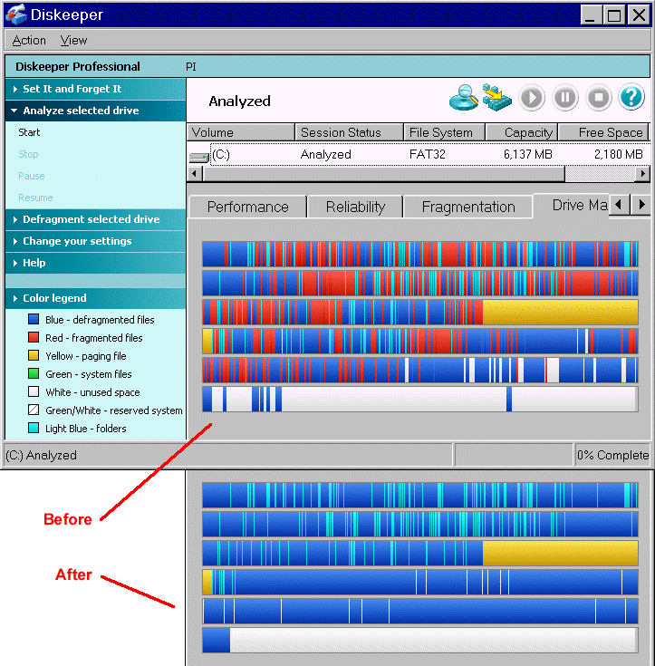](http://www.google.co.uk/url?sa=i&rct=j&q=&esrc=s&frm=1&source=images&cd=&cad=rja&docid=G7YqSPZ96FUu1M&tbnid=1sF5rqhLBRADNM:&ved=0CAUQjRw&url=http://www.pcmag.com/encyclopedia/term/41084/defragment&ei=VwD6UtbILMbL0AXy2YHQAQ&bvm=bv.61190604,d.ZG4&psig=AFQjCNE4Tpul3cfncQNvtPetfAHRKmJZNw&ust=1392202183784831)

**Defragmentation**

Defragmentation is a process that reduces the amount of fragmentation - the storing of a file in several separate areas of memory scattered throughout a hard disk. After this process is done, the operating system tries to fill the gap with new files that may be necessary to use. If the file is too big, it will be moved into another location for it to fit. This is a great way to boost the performance of the computer. Defragmentation is a useful tool because when you delete a file a gap is in place, which makes it harder for software or files to share data. All defragmentation removes the gap, which makes your computer much faster than before.

**Backup Utility**

Backup utility allows the user to copy an entire file to another storage disk. For example, copying your files from your disk to your USB is backing the file up. As it may get lost, you have it saved on another storage to reuse again. Windows includes backup utility that monitors progress of your files. It gives you a message/alert when the computer thinks that the files need to be backed-up. Some Back-up utility alerts you to back-up your files onto a CD or DVD.

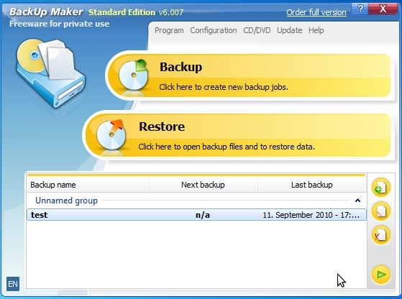

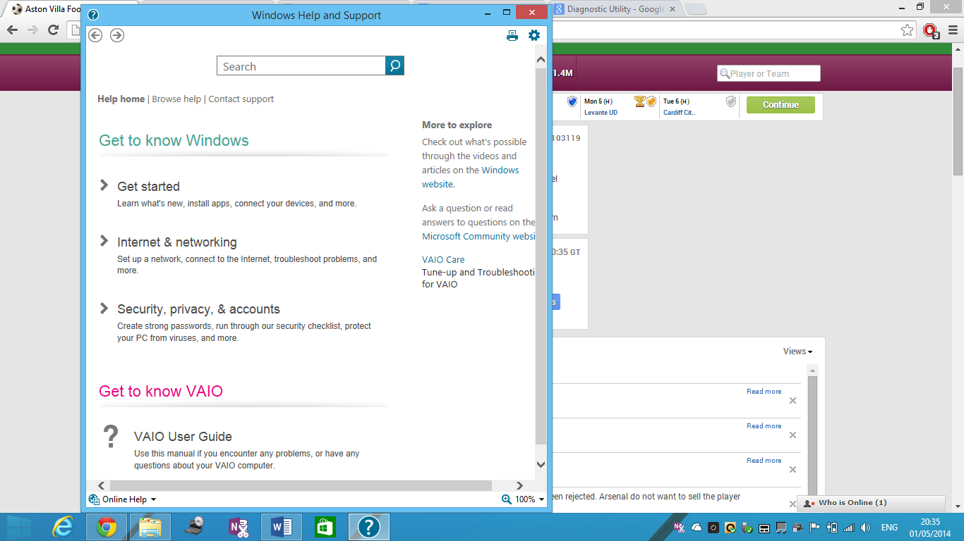**Diagnostic Utility**

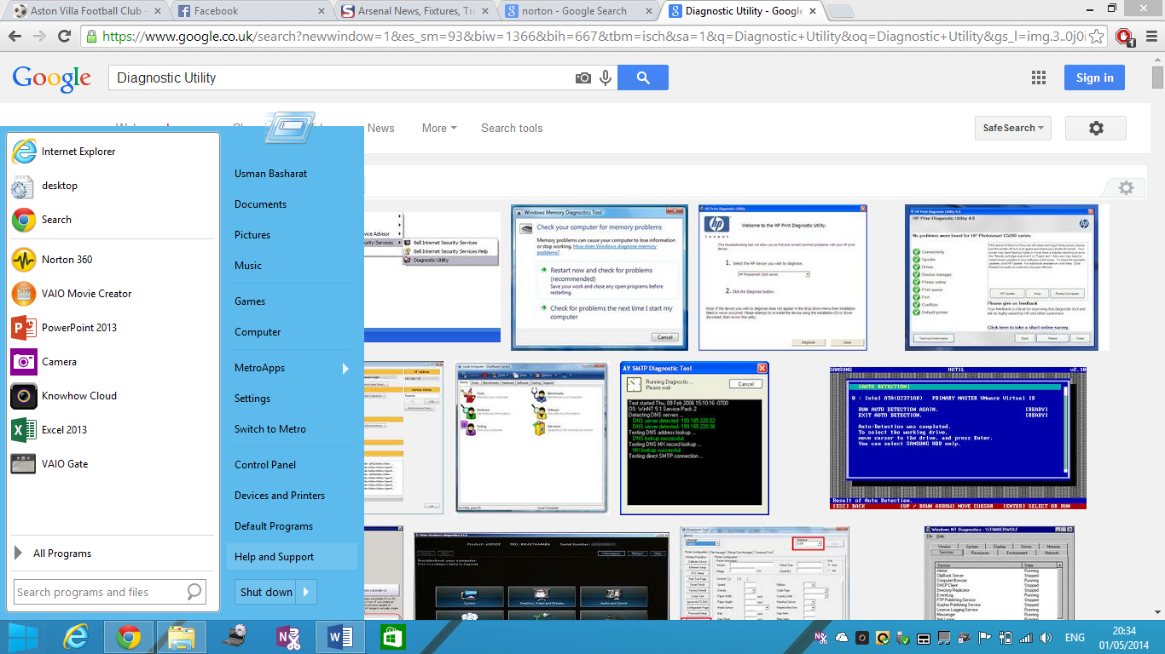Diagnostic Utility helps the user for any problems that they cannot solve. If the problem cannot be solved, it can be reported to Windows. ‘Help and Support’ helps on any topics. It also shows you if you are new to using Windows, it helps you the steps of how it works.

**D1**

If you are aiming for D1 ensure that you comment on the benefits of using that utility. Examples and background information would be beneficial. Remember to consider the knowledge of your customer. **[D1]**

**Virus Protection**

The protection of having anti-viruses is that it defects viruses. This is because the internet is not a safe place; they are full of viruses and hackers. If you have an anti-virus, it tells you which site is safe and which is not. This is important because if the user selects a virus website, it could cause many issues to the computer. Once viruses have infected your computer, they can extremely slow down your processing speeds, delete critical and important personal files and images, and in the worst case, cause permanently broken physical damage to your computer. Viruses can cost you thousands in computer-replacement costs and cause you to lose very important documents and photos. The best anti-virus software can prevent 99.99 percent of known viruses. The best decision is to keep a virus protection intact and download the one that suits you.

Figure 1.1

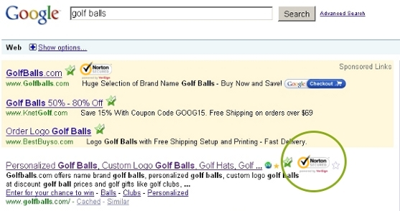  
Referring to Figure 1.1, it demonstrates how safe an anti-virus could be. Only click on the websites that is ticked by Norton. I personally think that Norton is very protective and deletes any unnecessary viruses that are there.

**Firewall**

The benefits of using Firewall are that it secures the computer network. It disallows other networks from entering your secured network. As it blocks other networks, it blocks viruses and hackers from entering the network. It acts like a secure “wall”. It does not let anything past it. For organisations who have secure data on their computers, it is vital that they tell/ask all employees to keep their firewalls ON. It is important and if anything is let past, it can access the files and the virus can spread/multiple quickly. Referring to Figure 1.2, it demonstrates how secure Firewall could be and how important it is.

**Clean-up tools**

The benefits of using Clean-up tools are that it gets rid of any unnecessary files that are on the machine. However, if this were not to be complete, it would make the computer slower and not fast. As the waste is not deleted, it would make the RAM full. Therefore, the user would not be able to use any more once the RAM is full. You would need to use an external storage device e.g. USB. This does not come free; you have to pay for a USB.

For example, if a computer has 1.79TB on its hard drive and it is full, the user would not be able to save anything on it. It is important to delete any unnecessary files that the user would not need and does not need.

**Defragmentation**

To perform house routine housekeeping on your computer, you must first perform defragmentation which can be done in 3 easy steps first go to your C drive click properties and select defragmentation from the options and run it until its complete. The defragmentation can help improve your system because it allows you to remove all the space between your data this means that the processor can read your work faster because there are no gaps anymore and by gaps. I mean that when you delete something of your computer, there are still folders making gaps between your data. Moreover, if you use defragmentation it removes all these folder/gaps and allows your processor to read your files quicker because it does not have to read the gaps in between. This means that the processors speed will be much faster and the computer will save RAM space because all the folders are going to be deleted from the computer.

[](http://www.google.co.uk/url?sa=i&rct=j&q=&esrc=s&frm=1&source=images&cd=&cad=rja&docid=G7YqSPZ96FUu1M&tbnid=1sF5rqhLBRADNM:&ved=0CAUQjRw&url=http://www.pcmag.com/encyclopedia/term/41084/defragment&ei=VwD6UtbILMbL0AXy2YHQAQ&bvm=bv.61190604,d.ZG4&psig=AFQjCNE4Tpul3cfncQNvtPetfAHRKmJZNw&ust=1392202183784831)

**Backup Utility**

Any users/organisations can gain a number of benefits by backing up important information. A backup is important because if you have important record on the computer e.g. customer records, it would be safe if it is backed-up. It would save a lot of time getting the files back if the user has lost it. This is why the user should have two copies of the file; one stored on the computer and another on a USB or CD. Backups are coming more and more vital as organisations depend on computers and the data they store. Many organisations take many risks without even knowing it. It is better to keep another copy of the backup file in another location where it is secure and accessible. If the organisation has lost the file/data, they will have to type up the information again which is time-consuming.

**Diagnostic Utility**

It shows you the problem and a solution, which is great as the user, can pick the specific problem they have. It is important that the user knows how to use a computer. It shows you steps of what to do, how to do it and where it is it going to be. Referring to the image, it demonstrates where to find the answers. The benefits are that it is easy and fast to find if you are having trouble. All the user needs to do is search up what the problem is and it will tell you straight away. Moreover, if the problem does not solve, you can report it to Windows. It produces a report outlining the problem. If the problem does not work, you can report it to Windows.